Eclipse setup for ADOpT project

1. Import projects from folder where you have “cloned” them (from bitbucket).
2. In Eclipse: window/preferences/java/build path/class variables and create new folders (Figure 1 and Figure 2).

* LIBRARY_FOLDER -> put the path of the library folder under “database” (Ex. C:/java/jpad/libraries).
* ECLIPSE_FOLDER -> put the of path of the “plugins” folder under Eclipse (Ex. C:\Program Files\eclipse\plugins)
* JAVA_JDK -> Put the path of Java Development Kit (Ex. C:\Program Files\Java\jdk1.8.0_25).

1. To run a .java file which uses an hdf5 library (to read a database), it’s necessary to create an environment variable called “Path” (Figure 3).

* Run/Run configurations/Environment/Path -> put the path of hdf5 library. Ex. c:\java\jpad\libraries\hdf\ (Copy/paste the path).

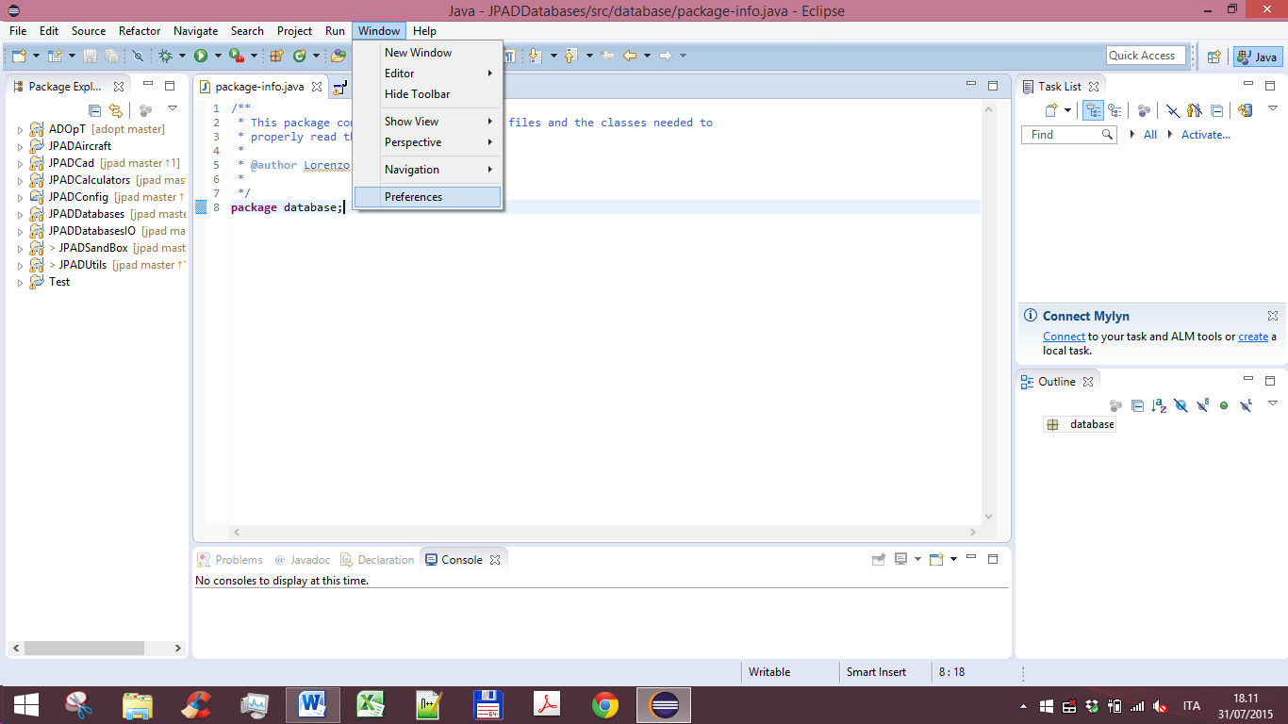

Figure 1

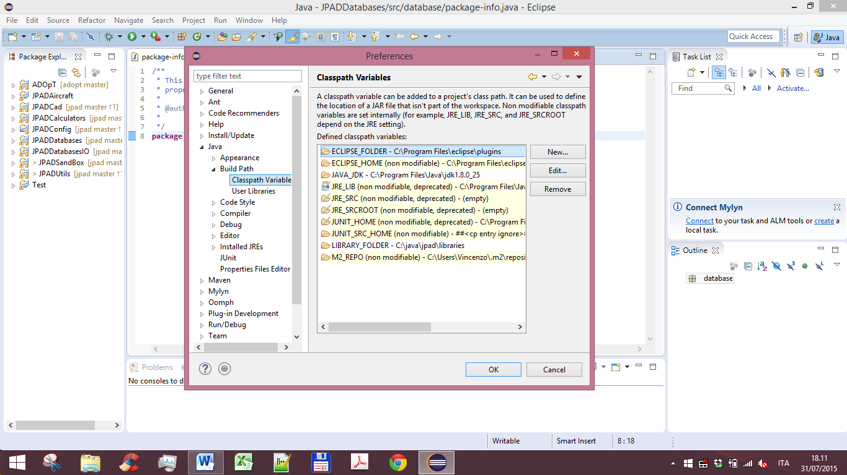

Figure 2

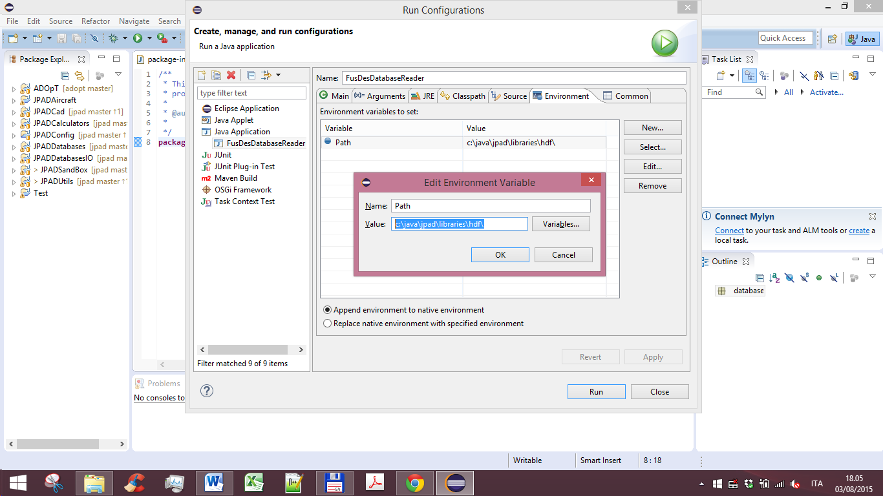

Figure 3

Below an example of environment variable settings in a “Run configuration”. See variables “MMGT_OPT” (needed by OpenCascade, OCC), “occjavaDir” (needed by OccJava), “Path” (that need to point to various Win64 DLLs and library files)

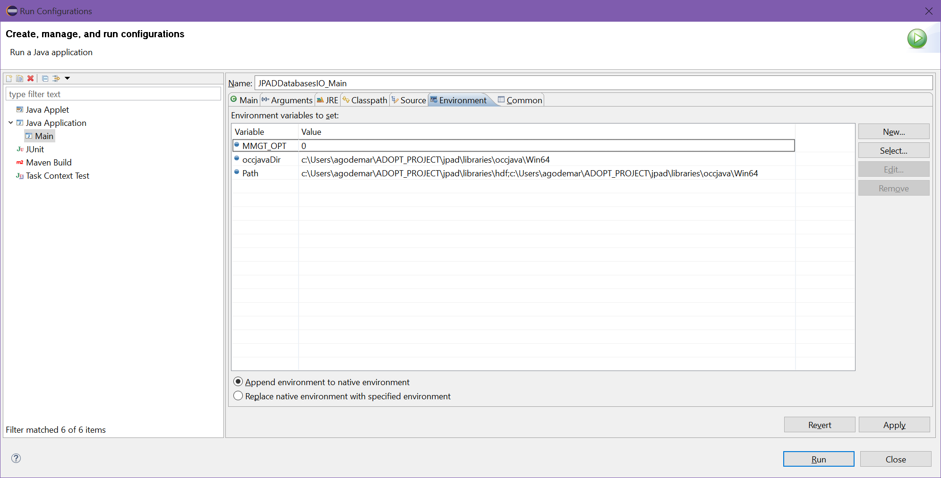

Figure 4